Name: M. Moiz Ansari Section: F Date: 11-3-2026

Wiegers Requirement Prioritization

Scenario: A University wants to develop a University Course Registration System that will allow students to manage their courses online. The system should simplify course selection, registration, and academic management.

Stakeholder: University Administration (Registrar Office)
Their goal is to manage course registration efficiently and avoid scheduling or enrollment issues.

Requirements with Justification (According to the Stakeholder)
Req | Requirement | Relative Benefit |  | Relative Detriment | Stakeholder Reason
R1 | Students can view available courses | 6 | 3 |  | Helpful for students but the university can still publish course lists through other channels (email/notice boards).
R2 | Students can register for courses online | 9 | 7 |  | Core functionality. It automates registration and reduces manual workload for the administration.
R3 | Students can drop or swap courses | 4 | 7 |  | Useful feature, but if missing it creates many manual requests and administrative burden.
R4 | Students can view their timetable | 2 | 1 |  | Convenient feature but not critical since timetable could be shared through PDFs.
R5 | Students receive deadline notifications | 4 | 9 |  | Not implementing it can cause students to miss deadlines, creating complaints and administrative problems.
R6 | Students can view prerequisites and eligibility | 4 | 8 |  | Important to prevent students from registering in incorrect courses which can create academic issues later.

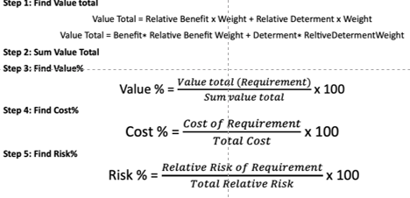
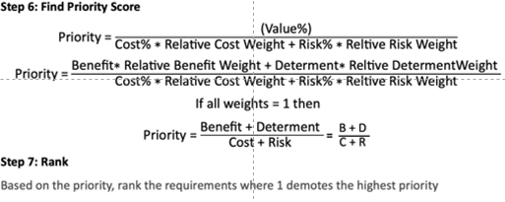

Weights | 2 | 0.5 |  |  | 1 |  | 1
Requirements | Relative Benefit | Relative Detriment | Value Total | Value% | Relative Cost | Cost% | Relative Risk | Risk% | Priority | Rank
R1 | 6 | 3 | 13.5 | 17.88 | 2 | 11.11 | 1 | 7.69 | 0.95 | 1
R2 | 9 | 7 | 21.5 | 28.48 | 4 | 22.22 | 2 | 15.38 | 0.76 | 2
R3 | 4 | 7 | 11.5 | 15.23 | 4 | 22.22 | 2 | 15.38 | 0.41 | 4
R4 | 2 | 1 | 4.5 | 5.96 | 1 | 5.56 | 1 | 7.69 | 0.45 | 3
R5 | 4 | 9 | 12.5 | 16.56 | 4 | 22.22 | 4 | 30.77 | 0.31 | 6
R6 | 4 | 8 | 12 | 15.89 | 3 | 16.67 | 3 | 23.08 | 0.40 | 5
Total | 29 | 35 | 75.5 | 100 | 18 | 100 | 13 | 100 | 3.28 | 21

